Record No: 0621
HUGH STEVENSON

Husband of Dorothea Victoria Somerville (0620).
Birth: March 1842 Galgorm, Co Antrim.Parents:Robert and Elizabeth Connaghty Stevenson.
Marriage: 24 January 1870, Dorothea Victoria Somerville, Cleveland, Ohio
Death: 1915, Jericho, Bosanquet Twp, Lambton Cty, Ontario. : Chronic Heart Disease, one year
Buried:Beechwood Cemetery, Forest, Ontario.

Notes: Hugh emigrated to Canada in 1854 with his parents and siblings from Grace Hill Moravian community in Ahoghil, Co Antrim.
Hugh was the youngest child of Robert Stevenson and his wife Elizabeth Connaghty Stevenson. Their issue were:
John Stevenson, born Ireland, May 19, 1824 (d London, ON, 1895), married Sophia McLeod
Samuel, born Ireland May 2, 1827 (died London, ON 1893), married Mary Keown
Sarah Jane, born Ireland Sept 13, 1829 (died London ON 1916), married in Ireland to Robert Clare
Eliza Margaret, born Ireland May 4, 1832, died in canada
Mary, born January 24, 1834 in Ireland (d. Bosanquet Twp., Ontario 1915), married Hugh Clark
Nancy, born Ireland Febrary 7 1837 (d Bosanquet Twp., Ontario 1921), married David Sloan
Rosa, born Ireland October 22, 1839 (d. London, ON 1921), married Sam Sloan
Hugh, born Ireland, March 1842 (d. Bosanquet Twp. Ontario 1915), married Dorothea Somerville

Robert was the last of five brothers, sons of John Stevenson and Mary Rankin Stevenson to leave Ireland. Between 1845 and 1849 a severe potato blight had affected the potato crops in Ireland with disastrous effects for the population. It is known as The Great Famine. Times were hard for Protestants, politically, socially, and economically, but they were much harder for the Catholics, who had few voting rights, and no land ownership. Robert and Elizabeth and their eight children were not as badly off as many, but dreams of better lives were dominant in their Moravian Community. Their oldest sons John and Samuel left home in 1848, and we know from his obituary that Sam lived for a year in Lower Canada, possibly with Uncle Philip. Robert emigrated 1852. Sam saved enough (hopefully with contributions from his father!) to return to Ireland in order to bring back his mother Elizabeth, his younger sisters and Hugh, in 1854. Sister Sarah Jane remained behind in Ahoghill with her husband Robert Clare and their older children, but they also came to Canada in 1857, staying on a second small home on the property with her parents, Robert and Elizabeth. Sam met Mary Keown on the boat back to Canada, and they married in 1856, returned to London, and he became a brickmaker in Westminster Township for seven years.
The journey to the new land took about six weeks, and was made on an open sail boat. Many immigrants at that time, mainly from Ireland, died on or after the journey as a result of cholera or other disease. The Stevenson family bible from 1772 survived the journey in their pine trunk, but suffered salt water damage. The family brought seed potatoes for their new life, but apparently needed to eat them en route. They also brought cock-fighting regalia. Family lore says that Hugh had stowed away on the trip to Canada, to save money on fares!
To encourage settlement, the Crown gave any British Citizen land, free of charge, if he or she fulfilled certain settlement duties: the settler was obliged to clear five acres of land for each 100 he wished to claim, open a road in front of his lot, and build a log house of at least 16 feet by 20 feet, and occupy it! If these stipulations were completed within 18 months, the Crown issued a patent to the settler, indicating that the ownership of the land had passed from the Crown to the individual.
Many settlers were well established in their places of origin, but came to Upper Canada to improve the prospects of their families or to escape deteriorating social and economic conditions. Settlers often travelled in family groups and came out to join relatives already in Upper Canada. Brothers William and Robert migrated from Gracehill, Ahoghill as part of a group of seven families who all settled in the Crumlin area: Stevenson, Sloan, Clark, Clare, Kernohan, Gamble and Russell. The families intermarried. John Gamble and Hugh Stevenson seem to have been life-long friends, as they both married Somerville sisters, John to Eliza in Thorold and Hugh to Dorothea in Cleveland. John returned to London for awhile as his first child was born there, but he migrated to Cleveland where Hugh later joined him at the end of 1869.
In 1861 Hugh was living in London with his parents and sister Rosanna. He was listed as absent from home. His parents` home was next door to Robert Clare and Hugh's sister Sarah Stevenson Clare, who had immigrated in 1857 according to census report. By November 1866, Hugh had purchased a farm at Lot 11, Concession 8, Bosanquet Twp, but he didn’t live there for very long, as he had moved to Cleveland by January 1870, when he married Dorothea Somerville.
Aunt Dollie, granddaughter of Hugh and Dorothea says of Hugh: "He could have been very prosperous but he was sort of a rover, and he liked cockfights. I don't know what took him to Cleveland, I guess just drifting about. He was a policeman in Cleveland and voted there and he never was a citizen, they was not so fussy then. Granny fell in love with him because he was so handsome. He was red haired and had long red whiskers. I sat on his lap and braided and combed his hair and whiskers when I was wee and he liked that. Granny was educated and refined and very intelligent. Granny was a pianist and elocutionist. She gave me the blackthorn cane and granddad's grog jug because I was the only daughter of the eldest son. The names Corry and McElroy as I remember are family friends. One of them was the name of a beau of Grannys before she fell in love with Granddad. She was 29 when she married and granddad was about 1-1/2 years younger and everyone twitted her about marrying such an old man.”
The first four children of Hugh and Dorothea were born in Cleveland: Somerville Bellingham Stevenson, Thomas McIlroy, Stevenson, Rosay and her twin, Quayle, who died as an infant. Hugh and Dorothea and their oldest children returned to the farm in Canada in 1877, where Robert Corry was born in 1880. The family continued to reside at ‘the home place’, where both Hugh and Dorothea died, and Robert Corry lived at the farm until just before his death in 1965.
The home was originally a one story log building, which met the Settlement Duty of the original patent owners, but Hugh added a second storey and a back porch to accommodate his growing family, and also built a large barn. For part of the time, two of Dorothea’s nieces from her deceased sisters Henrietta (Mysie Street) and Lucinda (Ida MacKinnon) lived with the family at the farm. At one time he attempted to operate a brickyard, with his brother John, on the farm opposite him on the 8th Concession. Apparently most of the brick homes in that area were made from Stevenson brick, but the business eventually failed as the farm did not yield enough clay to make the bricks. Several Gamble and Stevenson men were brickmakers, and apparently John Gamble and Hugh Stevenson had arms ‘like tree trunks’ as a result of their work at their brickyard in Cleveland.

Degree of the Loyal Orange Lodge, No 230 is granted to Brother Hugh Stevenson on 18th day of July, 18?? And signed by [his brother in law] Deputy Master Robert Clare. Ahoghill Loyal Orange Lodge #230 was originally founded in 1838 with a new warrant being issued to North Dorchester, Ontario area in April, 1848. The lodge was moved to Crumlin (now a part of London, Ontario) on February 23, 1850 and was named Ahoghill after the Irish home-town of some of the founders. The lodge initially met in a brick lodge room erected just east of Crumlin; near the Stevenson farms.

Source: Somerville Index and Wendy Stevenson.

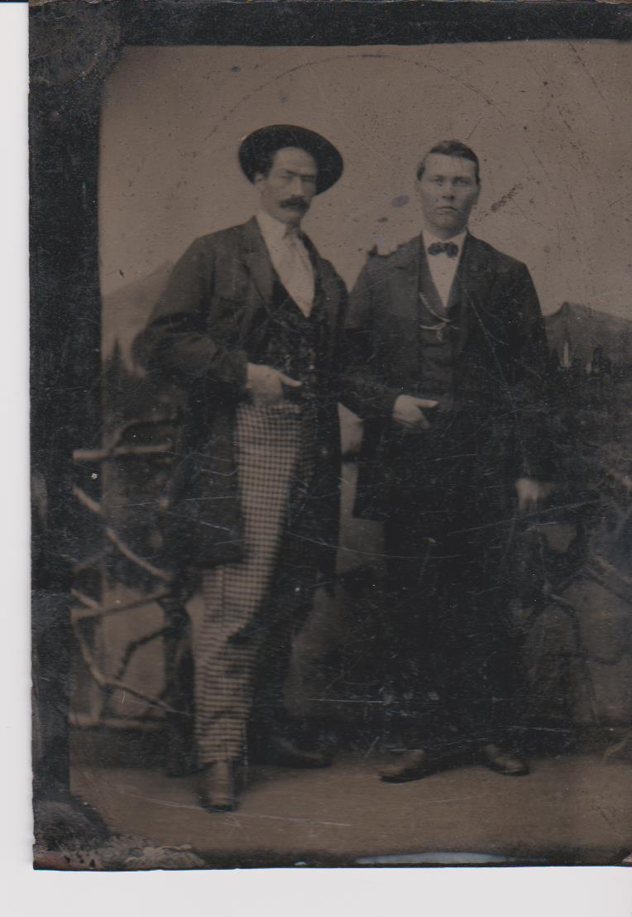
Hugh Stevenson, taken at about the time of his wedding in January 1860. Friend is possibly John Gamble, with whom he had a close relationship, and both men married Somerville sisters.

